**Inputs**

* 1 Integer from Keyboard

**Outputs**

* Message asking for user to input 1 integer
* Message displaying final answer
* Message asking if user wants to continue program or exit

**Variables**

* Output – BYTE for saying display function final answer: msgOutput
* Output – BYTE message for saying input integer for function: msgInput
* Output – BYTE for asking user if they want to exit program: msgExit
* Output – BYTE for formatting, space: msgSpace

**Algorithm**

1. Ask user to input an integer
2. Call a function(n), where n is user integer
3. If n <= 0, return 1
4. If n > 3, return function(n-2) + function(n >>2)
5. If 0 < n <= 3, return n << 2
6. Ask user if they want to exit or repeat program

**Flow Diagram**

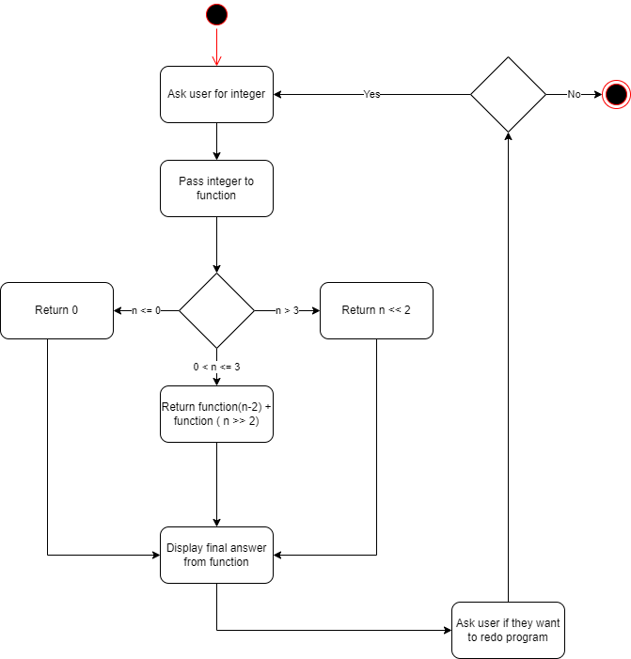

**Stack Diagrams**

**Falkor Function**

|  |
| --- |
| eax |
| return address |
| Old EBP |
| EDX |
| ECX |
| EBX |
| FLAGS <-ESP |